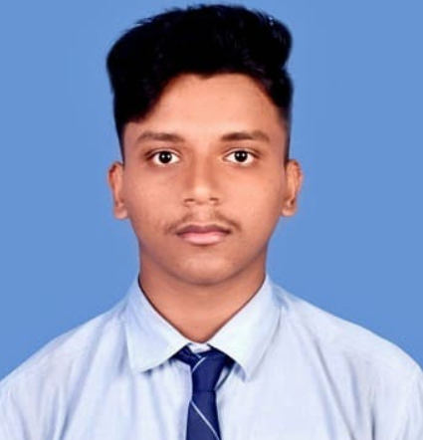 |  |  | Pritam Tung  pROFILE  Passionate Web Developer Programmer with hands-on experience in building responsive websites and innovative projects. Skilled in HTML, CSS, JavaScript, and Python, I thrive on turning ideas into functional, user-friendly applications. Developed and deployed multiple projects showcased on GitHub, demonstrating problem-solving abilities and a self-driven learning mindset. Eager to contribute my technical expertise and creativity to dynamic teams while continuously expanding my knowledge in emerging technologies.  Education  * June 2021 – May 2023  Tulia Sitala Model High School (Higher Secondary)  * September 2023 – June 2027  Hooghly Engineering and Technology College, Hooghly (Bachelor of Technology)  language  ★★★★☆ English  ★★★★★ Hindi  ★★★★★ Bengali  SKILLS  ★★★★☆ HTML  ★★★★☆ CSS  ★★★☆☆ JS  ★★☆☆☆ React  ★★★☆☆ PYTHON  ★★☆☆☆ JAVA  INTERNSHIPS  Frontend Development at (#CodeAlpha)  COURSES  Introduction to Python Fundamentals, Coursera
 | Tamluk, East Medinipur,721653,west Bengal
 | 9339768425
 | Pritamtung03@gmail.com
 | https://pritam-tu.github.io/pritam_56/

